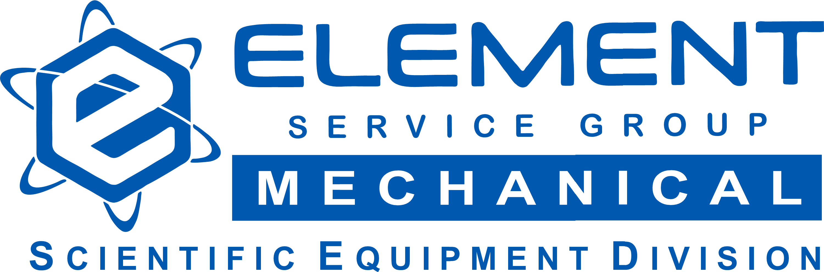

Lead Electrician

Company Description:
Element Service Group Mechanical provides top quality electrical & refrigeration service, installation, and technical assistance for Pharmaceutical, Biotechnology and Crop Science clients in the Raleigh-Durham area. We are growing our team to expand our client base and are seeking new team members with good technical ability, experience, work ethic and teamwork skill sets. We offer competitive pay, benefits, paid holidays and vacation plus simple IRA.

Job Description:

Commercial Electrician is a senior level position that involves but is not limited to:

- Extensive knowledge of the NEC code
- Wiring, bending/threading/cutting conduit, terminate devices, installing control panels
- Planning and implementing the installation of electrical utilities and control systems for environmental chambers
- Supervising journeyman electricians & junior assistants
- Electrical service, maintenance and repair of temperature & humidity stability chambers, plant growth chambers, industrial test chambers, cleanrooms & ultralow temperature freezers
- Industrial control panels with PLC, electro-mechanical and solid-state controls
- Utilizing equipment manuals and schematics to facilitate troubleshooting
- Training & supervising junior technicians as required

Requirements:

High school or GED
2-year technical degree and or equivalent electrical training. (Prior refrigeration experience is a bonus).
Unlimited or Limited Electrical license preferred (or state of origin’s equivalent)
10+ years field experience
Valid driver’s license
Drug-free
Intermediate computer skills – MS Outlook, Excel, Word
Good aptitude with electrical, system controls & power distribution
Attention to detail
Team player mindset with positive attitude and good energy
Self-supervising - work by direction of the division manager(s)
Must be able to lift up to 100lbs
OSHA 10 or 30-hour
NFPA 70E Electrical Safety
EPA Certification, Universal is a bonus
Must be able to read schematics, (Diagram, single line & ladder logic formats)

Compensation:

Hourly: $34-38hr (Based on qualifications, & previous work experience)
Paid vacation & holidays
Major medical insurance
Simple IRA

Summary:

Employment type: Full Time hourly
Job type: Skilled technical labor
Minimum qualification: High school or GED, plus 2-year technical degree or equivalent training
Experience: 10+ years
Manages others: Yes, depending on project requirements – some supervision of junior
technicians & assistants, as necessary.
Industries served: Commercial, Institutional, Pharmaceutical, BioTech, Crop Science
Required travel: Local to RDU – rare overnight or out of state travel
Hours & schedule: Standard 5-day work week plus overtime and on-call as required
Benefits: Major medical, disability, simple IRA
Compensation: $34-38hr (Based on qualifications & previous work experience)

